DISHES AND THEIR ALLERGEN CONTENT HUNTERS THE BAKERS LIMITED

Although strict procedures are in place to prevent cross contamination, our products cannot be guaranteed to be free from traces of peanuts, tree nuts (almond, hazelnut & walnut) & or sesame seeds as the allergen is handled on the site at the bakery.

DISH | 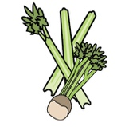 | 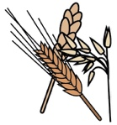 | 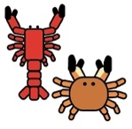 | 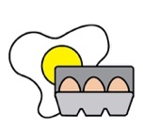 |  | 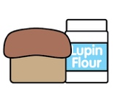 |  |  |  | 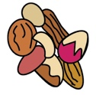 | 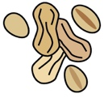 | 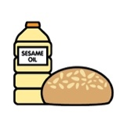
 | Celery | Cereals containing gluten | Crustaceans | Eggs | Fish | Lupin | Milk | Mollusc | Mustard | Nuts | Peanuts | Sesame seeds | Soya | Sulphur Dioxide
Meat & Potato pie/ pasty |  | YES  WHEAT |  | YES
Cheese & Onion Pie/ pasty |  | YES  WHEAT |  | YES |  |  | YES
Marrowfat Peas
Pickled Onion |  | YES  BARLEY |  |  |  |  |  |  |  |  |  |  |  | YES
Red cabbage |  |  |  |  |  |  |  |  |  |  |  |  |  | YES

Review date: | 24/08/2021 | Reviewed by: | N. T. HUNTER |  | You can find this template, including more information at www.food.gov.uk/allergy

